**CS 255 System Design Document Template**

This template lays out all the different sections that you need to complete for Project Two. Each section has guidance to prompt your thinking. You will need to continually reference the interview transcript as you work to make sure that you are addressing your client’s needs. There is no required length for the final document. Instead, the goal is to complete each section based on what your client’s needs are. Remove this note when you are finished, and replace all bracketed text with the relevant information

**UML Diagrams**

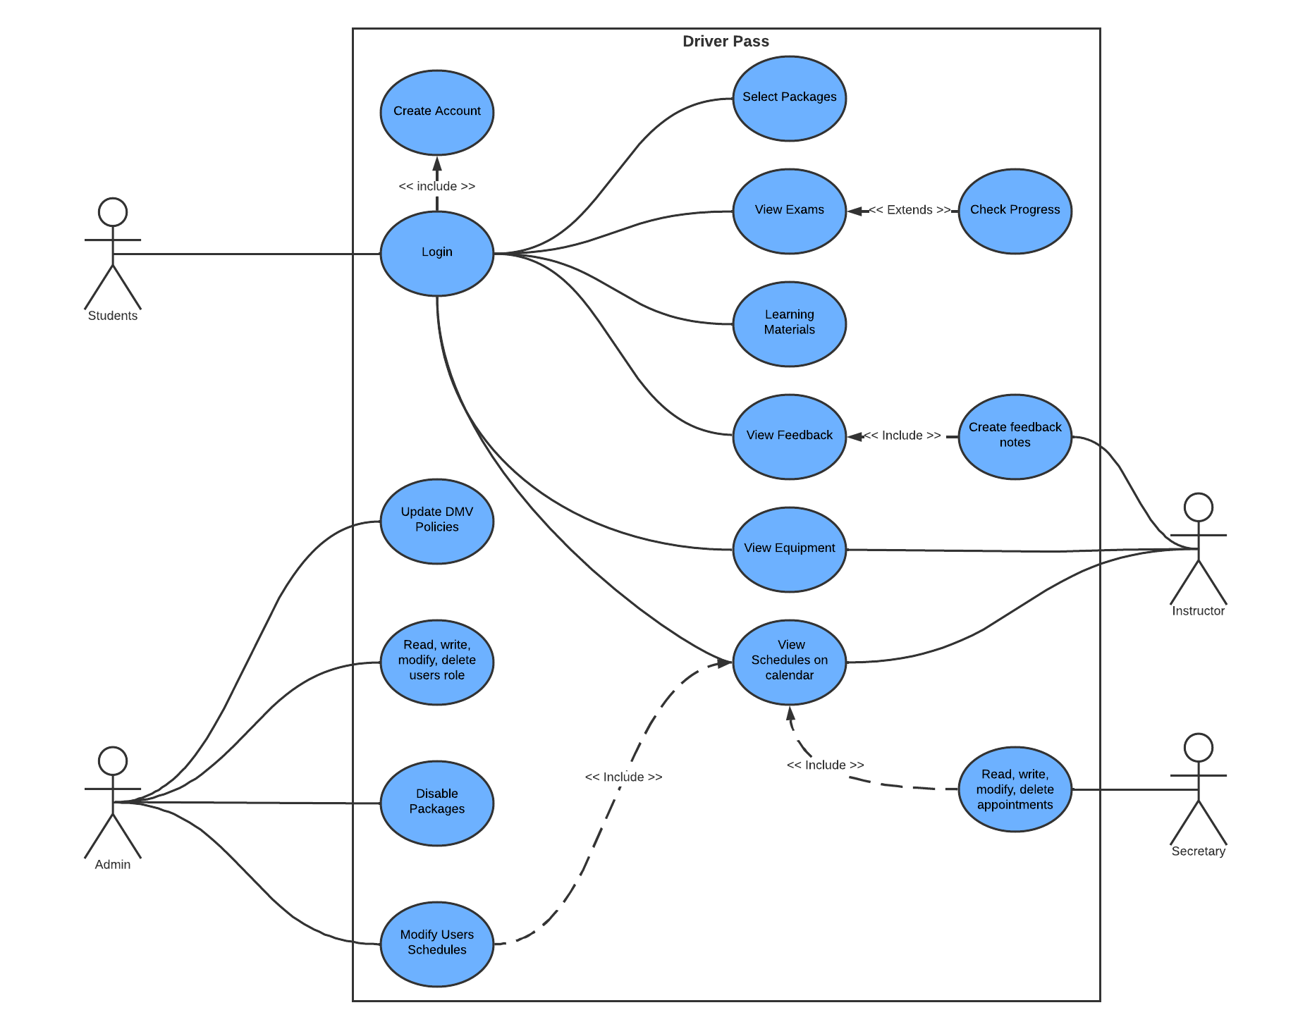

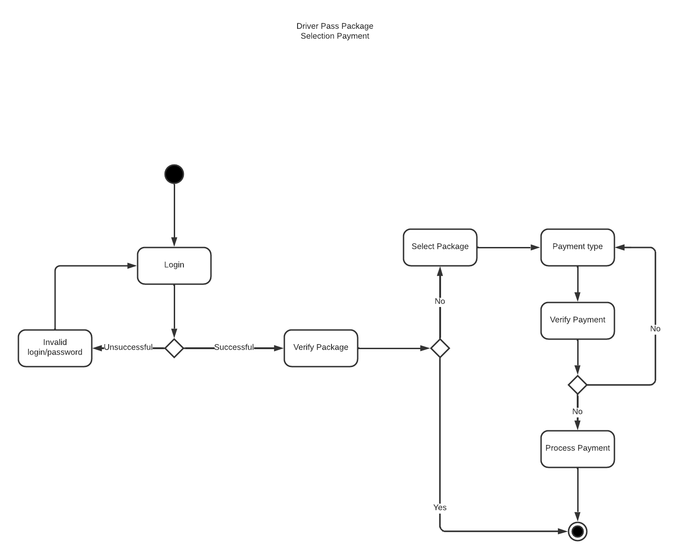

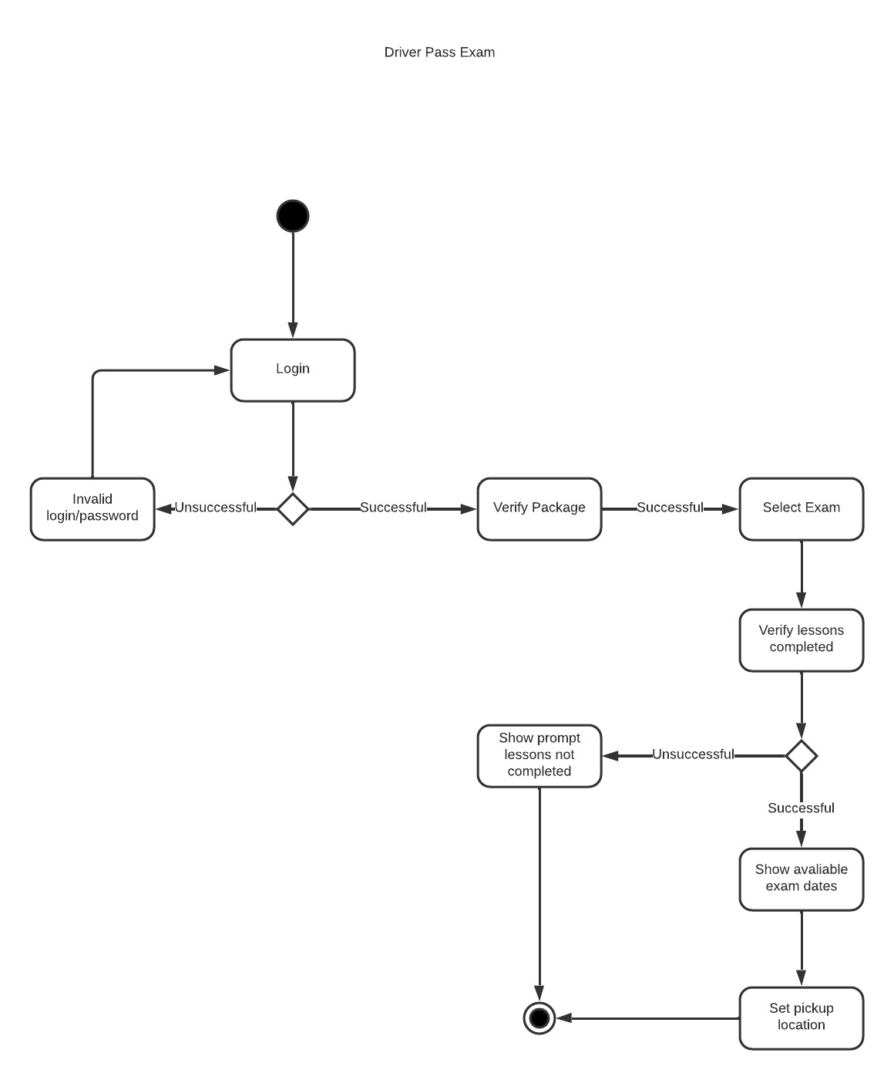

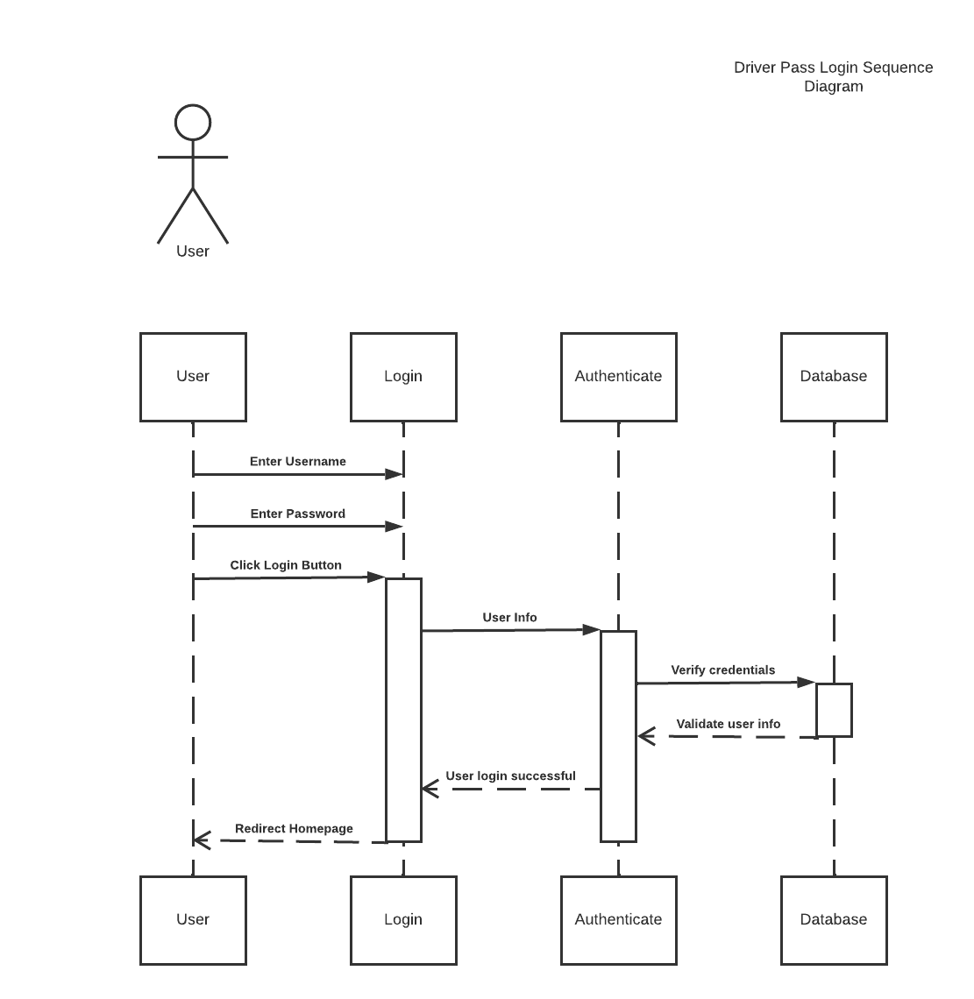

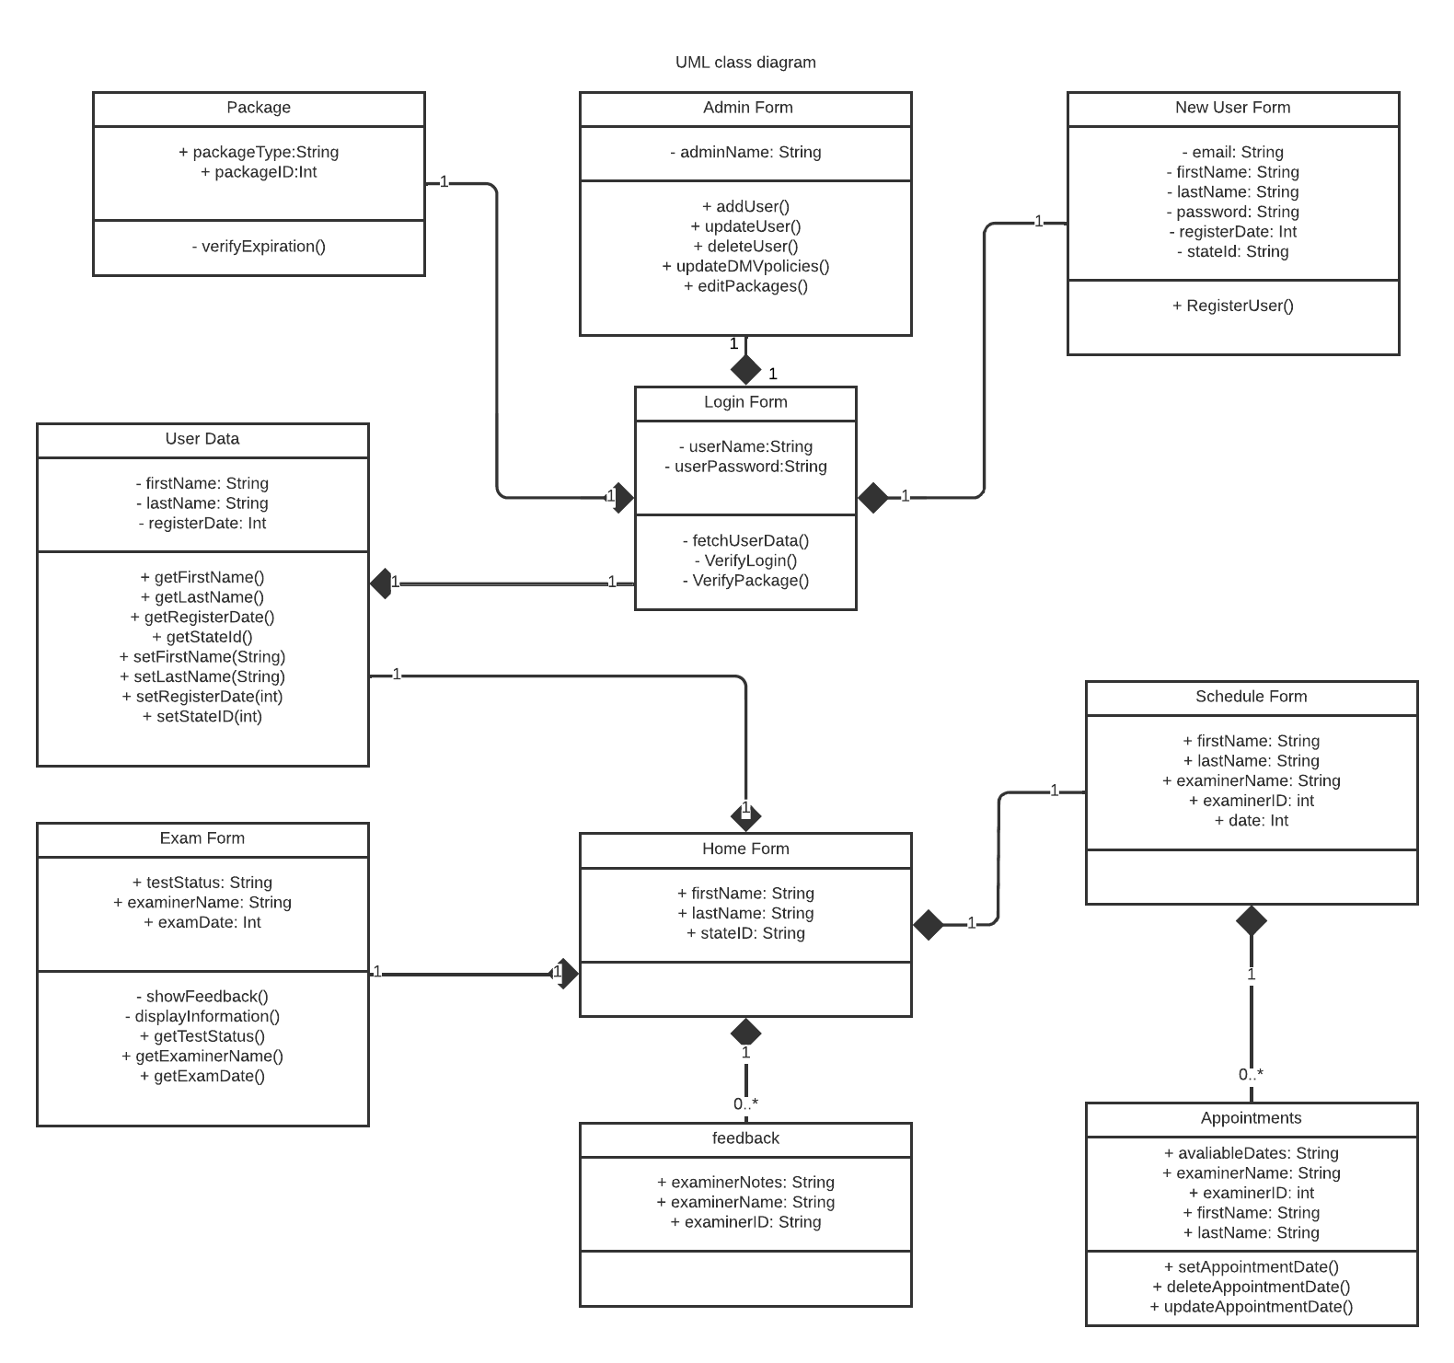

**Technical Requirements**

The application must be a web-based application and use cloud-based hosting services to be able to be accessed anywhere and modified as needed. The system will also store all examiners, users, learning material, locations, appointments, and test progress in the cloud reliably. Communication between the cloud and the application also must be encrypted as well as user to an application to avoid man-in-the-middle attacks and other vulnerabilities which can jeopardize the product or deny services that cost money.